***WEB 3.0 ASSIGNMENTS***

* Create MetaMask Account
* Get Free GoerliETH Through Faucet
* Send GoerliETH into MetaMask Wallet

**MetaMask Id**: 0x2e8e474149431b54352F302e1C95f901996F8BF3

**Etherscan URL:** <https://goerli.etherscan.io/tx/0xdc75039ddc16e988bb851f4289b9a2d479e5f5a78a6108ad76e7796665188ea5>

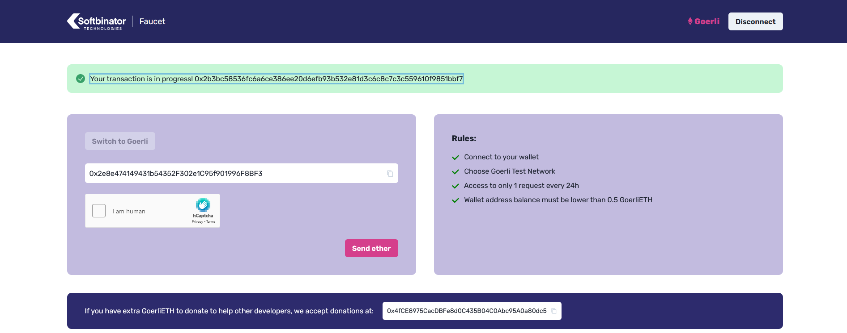

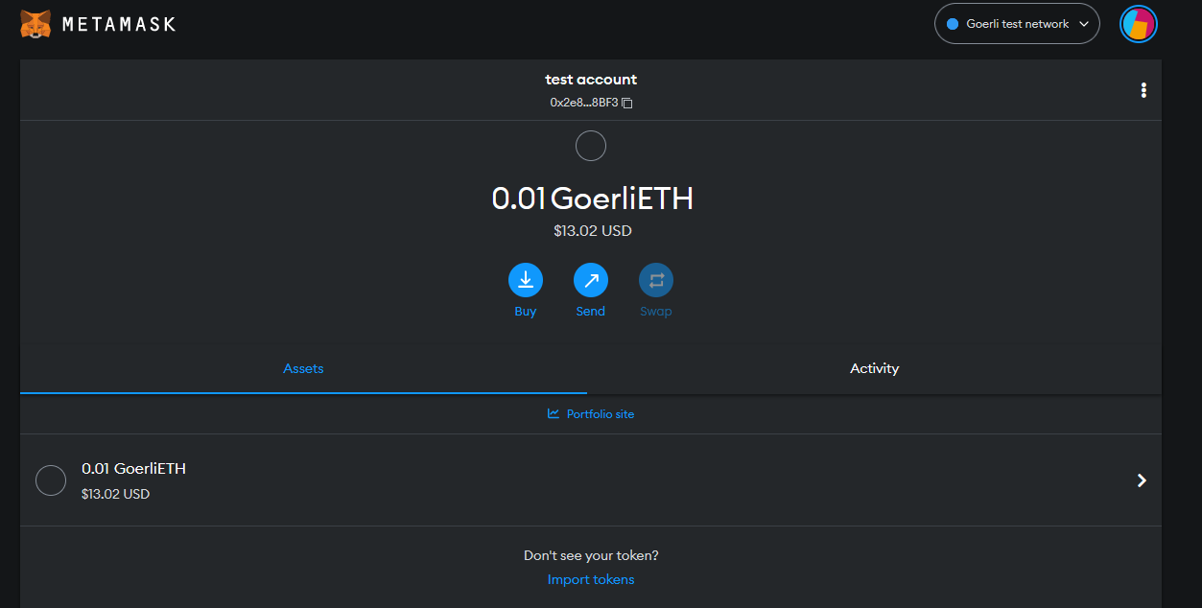

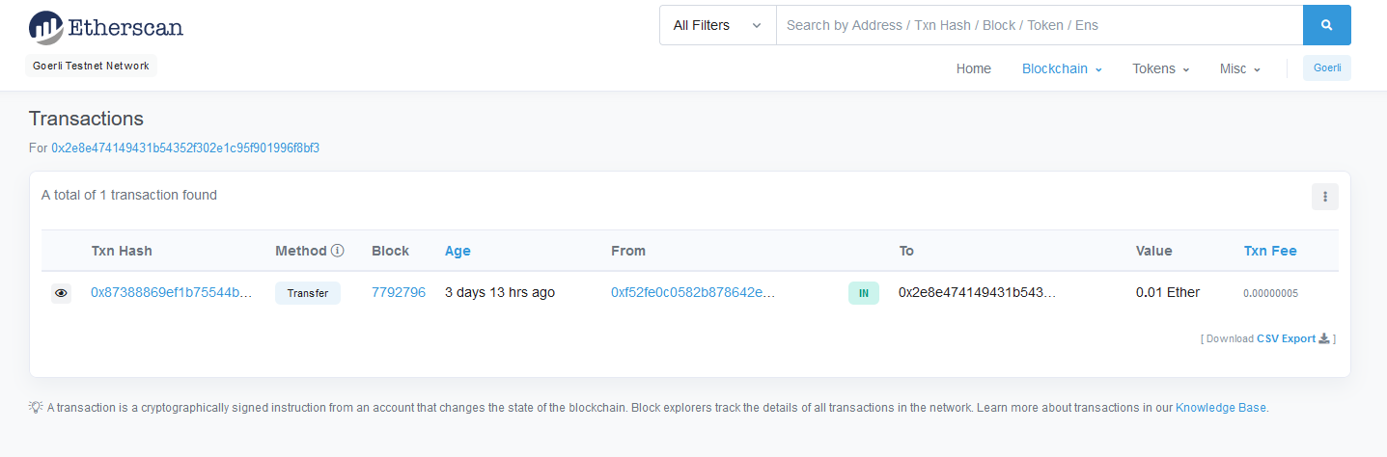

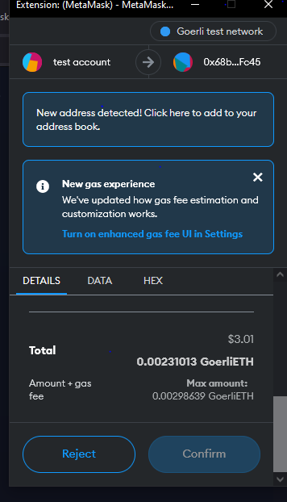

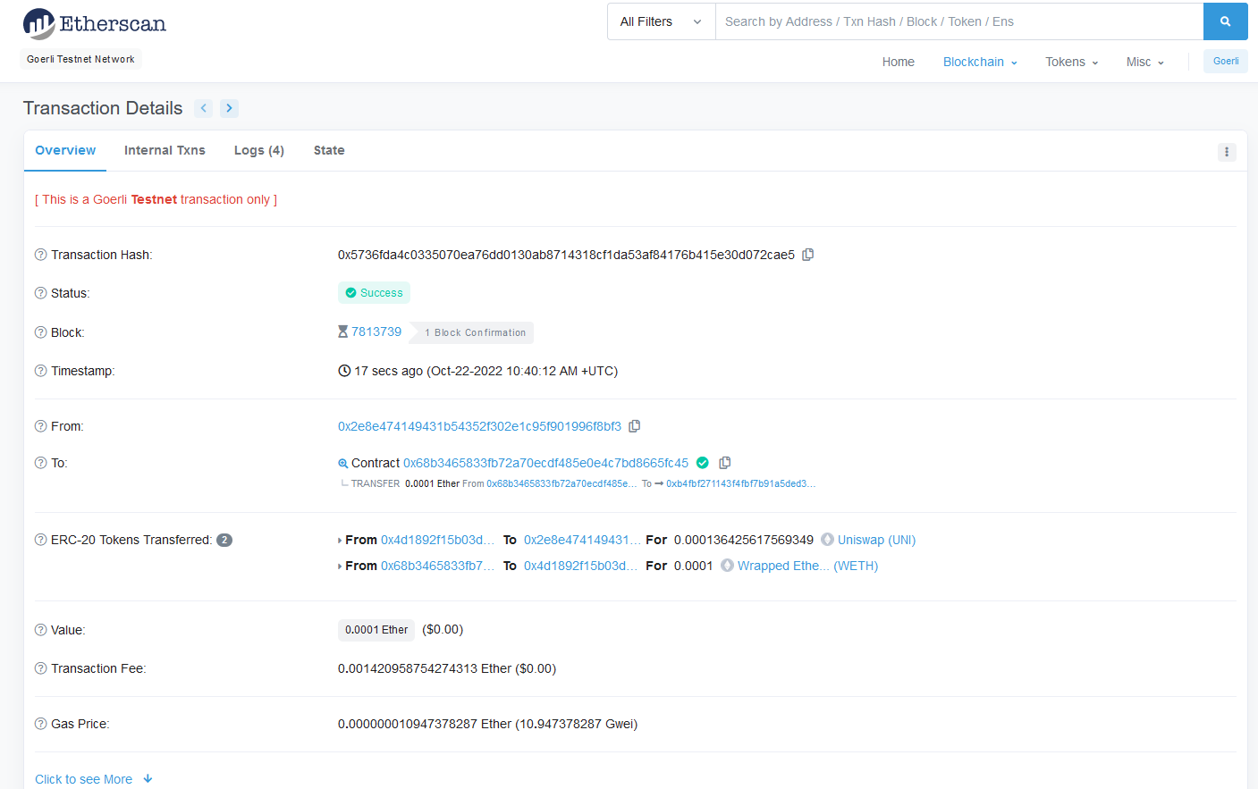

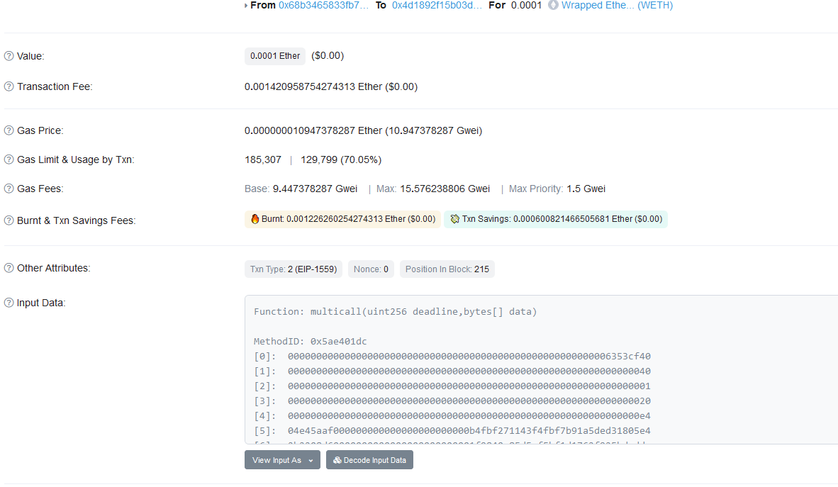

**ERC-20 Token:**

* Create your own token
* Send your token in your MetaMask Wallet

**Transaction Hash:** 0xd53bceaa3744feee4c016f8f648270d9e57fdda96715a8d7533a08dd8778efab

**Max Total Supply:** 10,000,000 MUSSII

**Token Name:** Musaib

**Symbol:** MUSSII

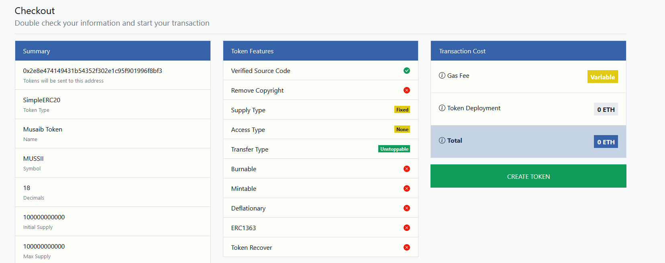

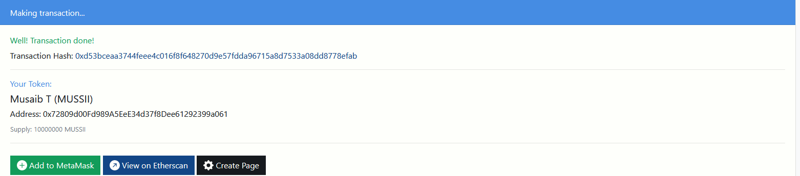

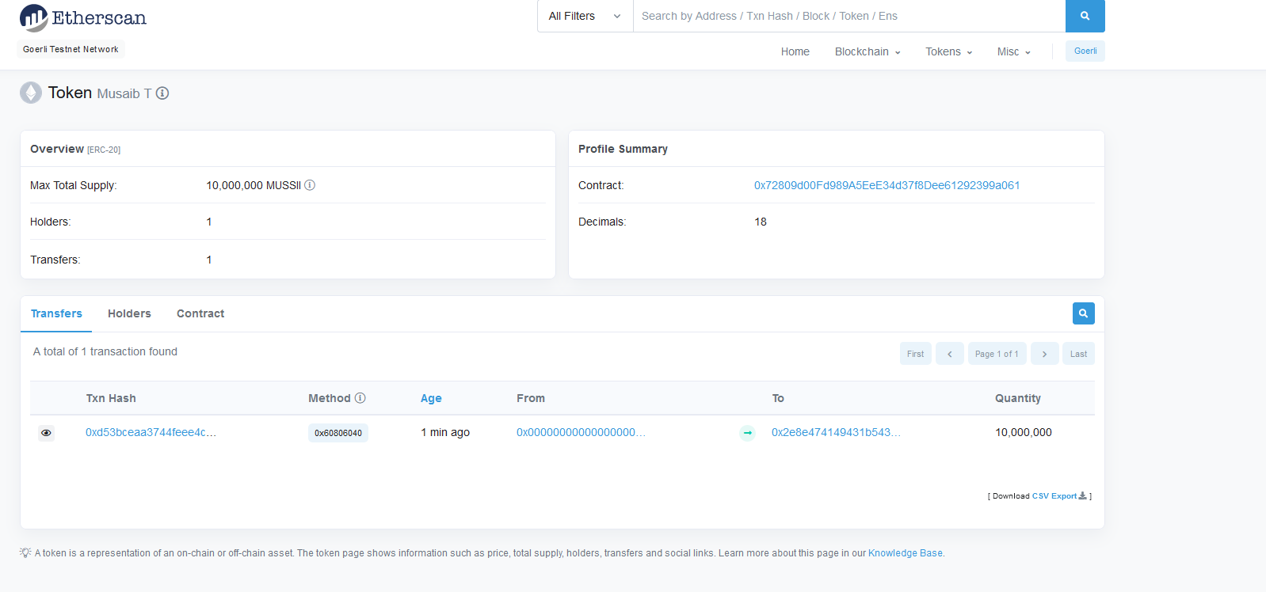

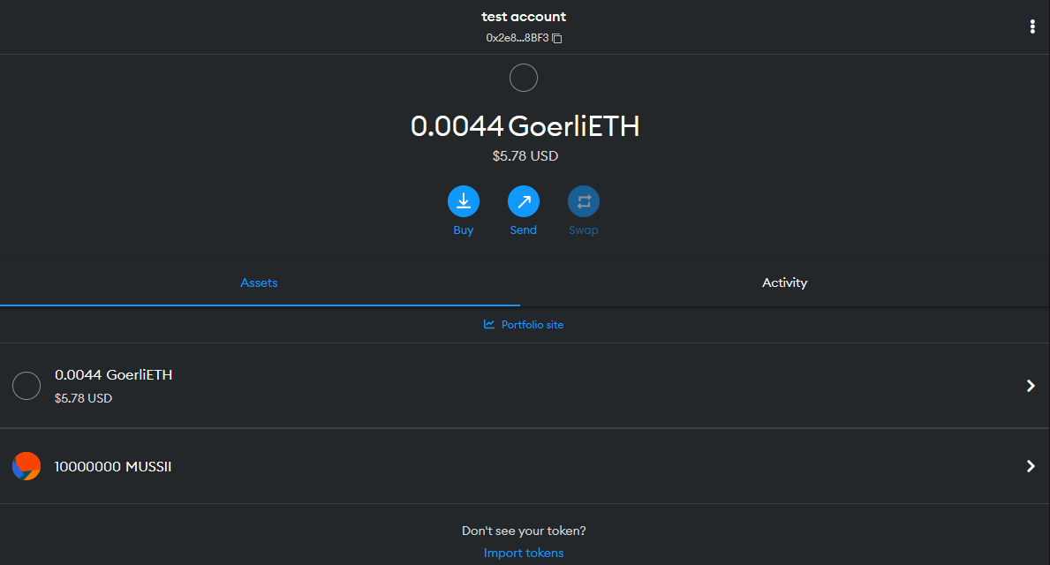

**AAVE:**

* Connect MetaMask Wallet
* Supply ETH
* Borrow ETH
* Send To MetaMask Wallet

**Supply Etherscan URL:** <https://goerli.etherscan.io/tx/0x02ca622256fa3943b6da333d3b5b7393643a715a9eceaaecc187269e75d69f42>

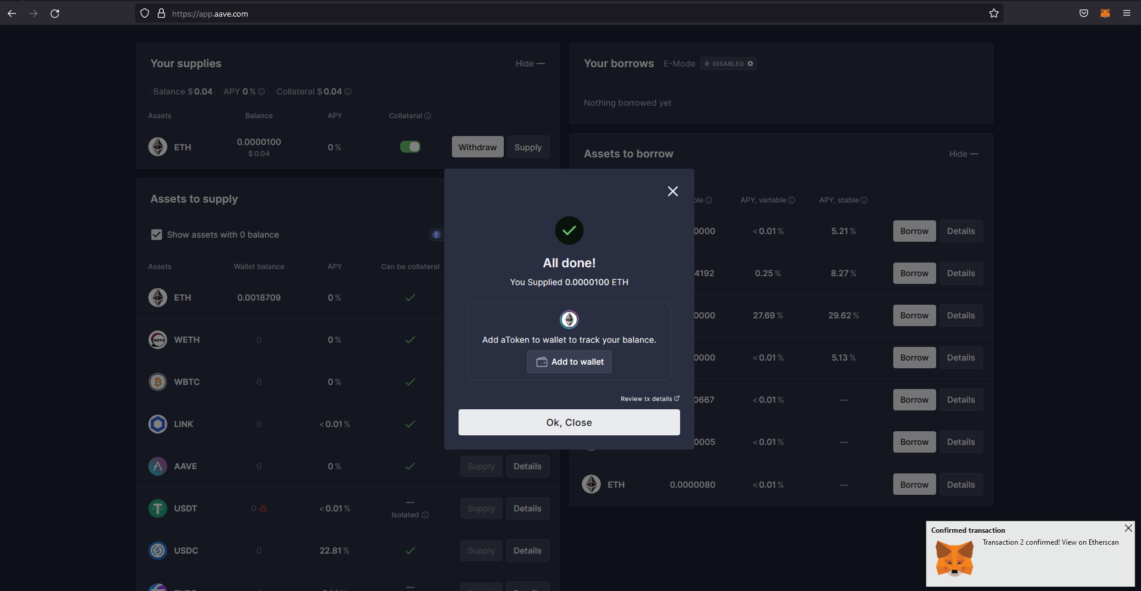

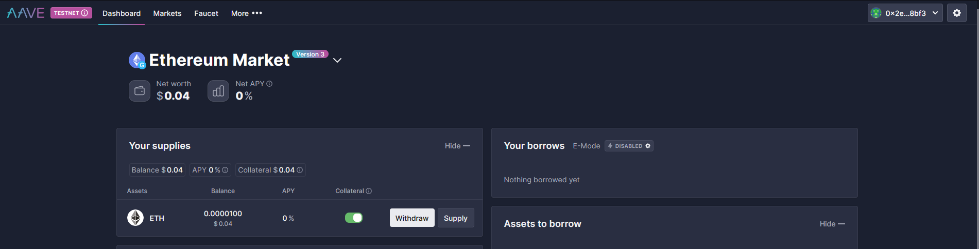

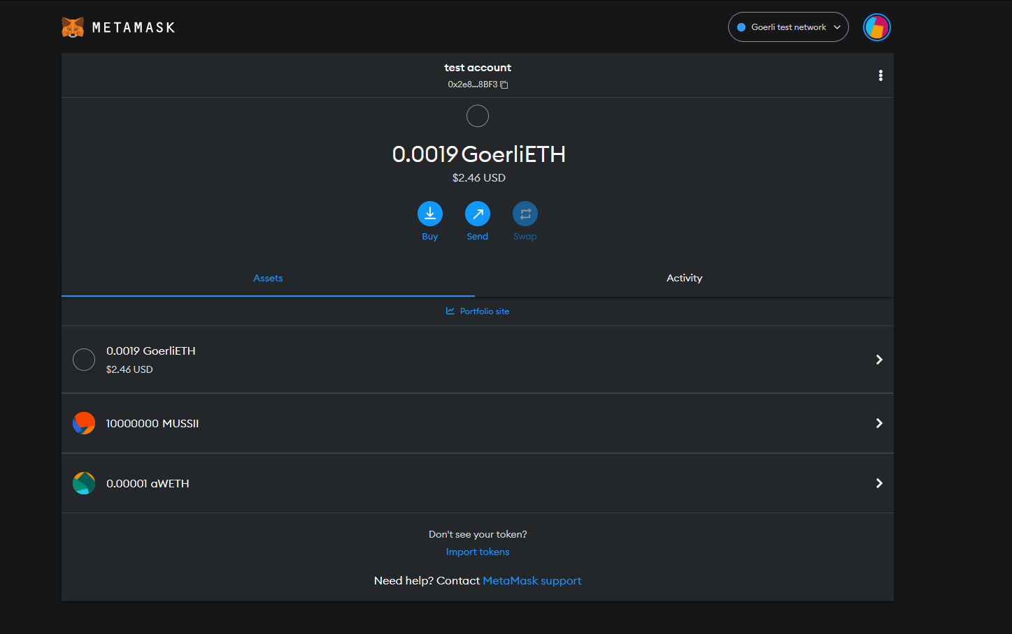

**Borrow Etherscan URL:** <https://goerli.etherscan.io/tx/0xa9913e592d332bc90a2767290e9dce5106bb47ca8f1507ec7f0432c60fa0e17e>

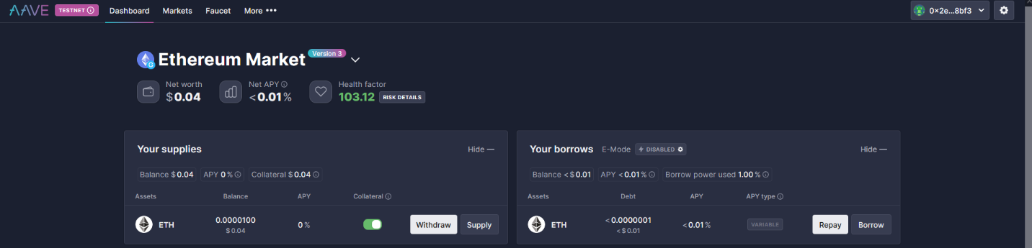

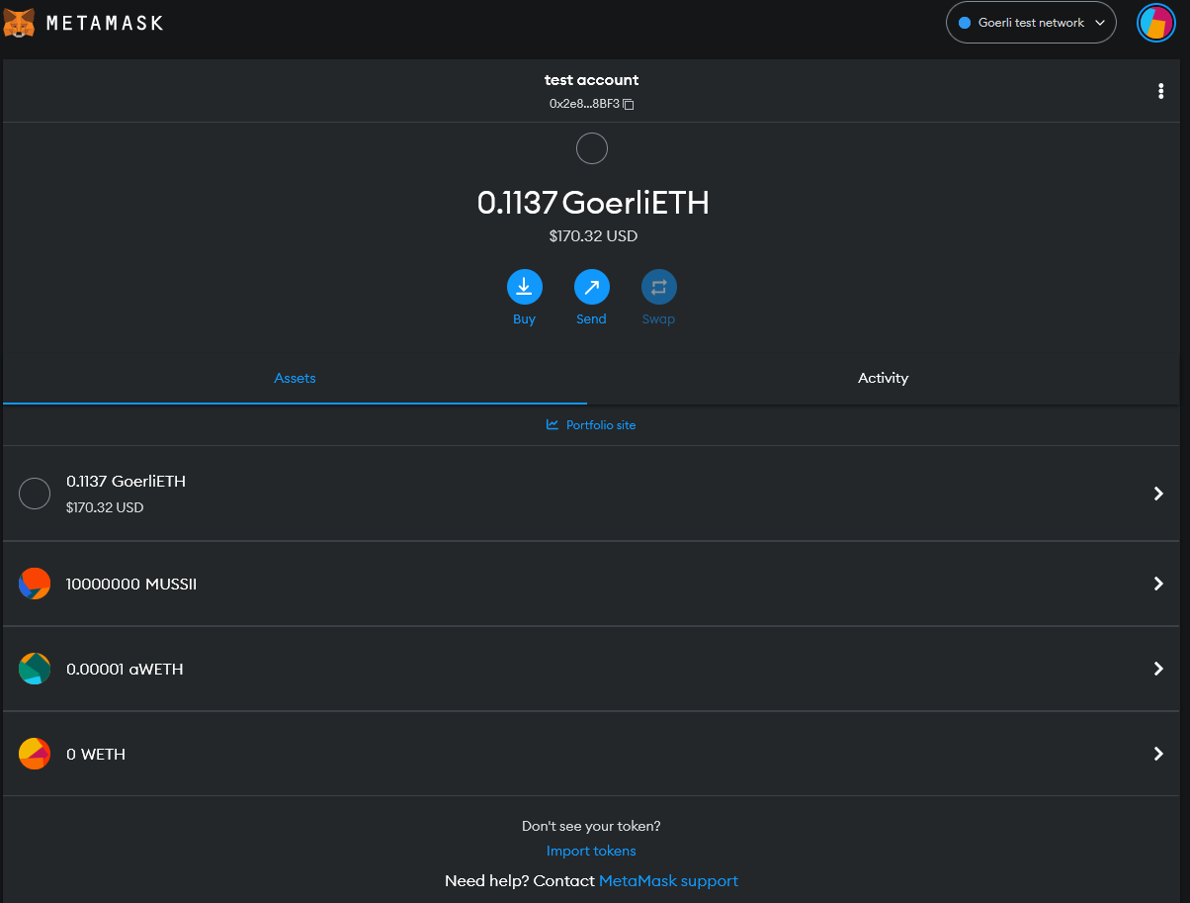

**UNISWAP:**

* Connect MetaMask Wallet
* Import Your Token From MetaMask to UniSwap
* Create Liquidity Pool On Uniswap

Your own token Uniswap Pool URL: <https://app.uniswap.org/#/pool/39320>

**Ethescan URL:** <https://goerli.etherscan.io/tx/0xe4fd689caaf14db20e198bfdf747f9550177b335a60b06d69b3a8e37c4799dac>

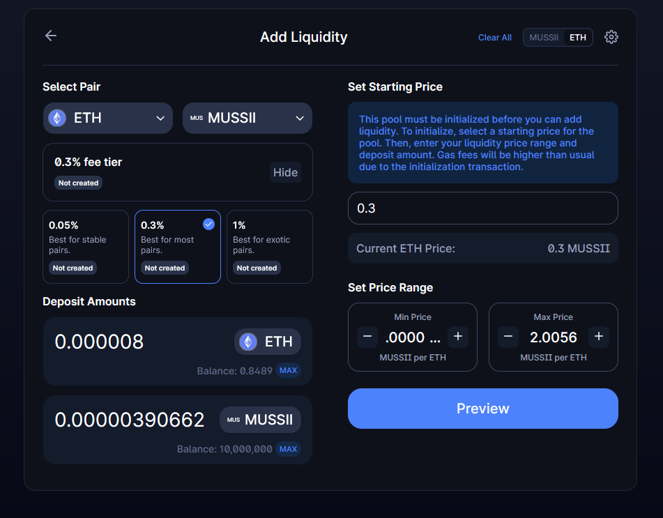

–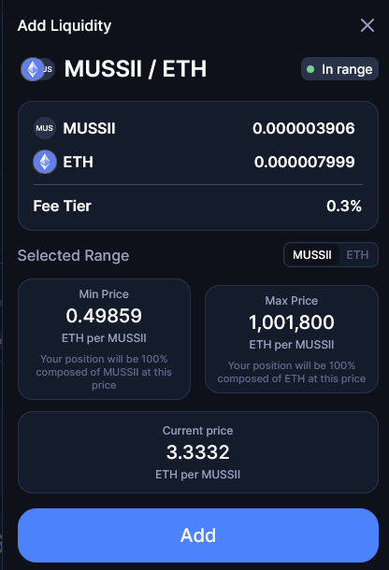

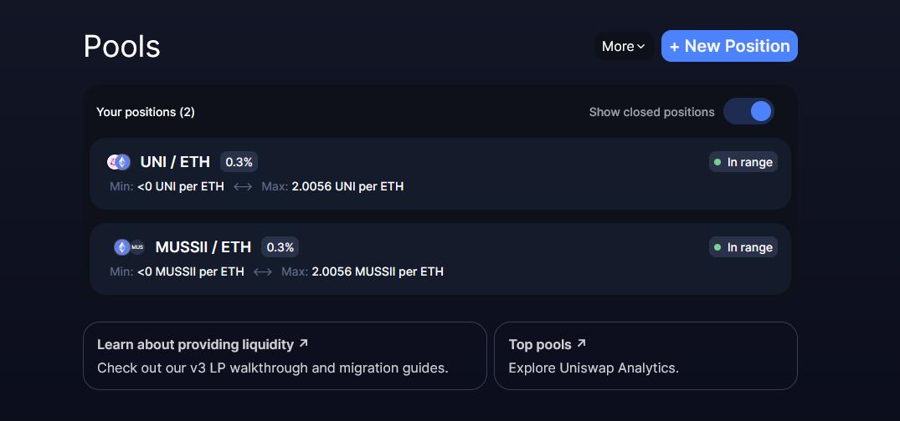

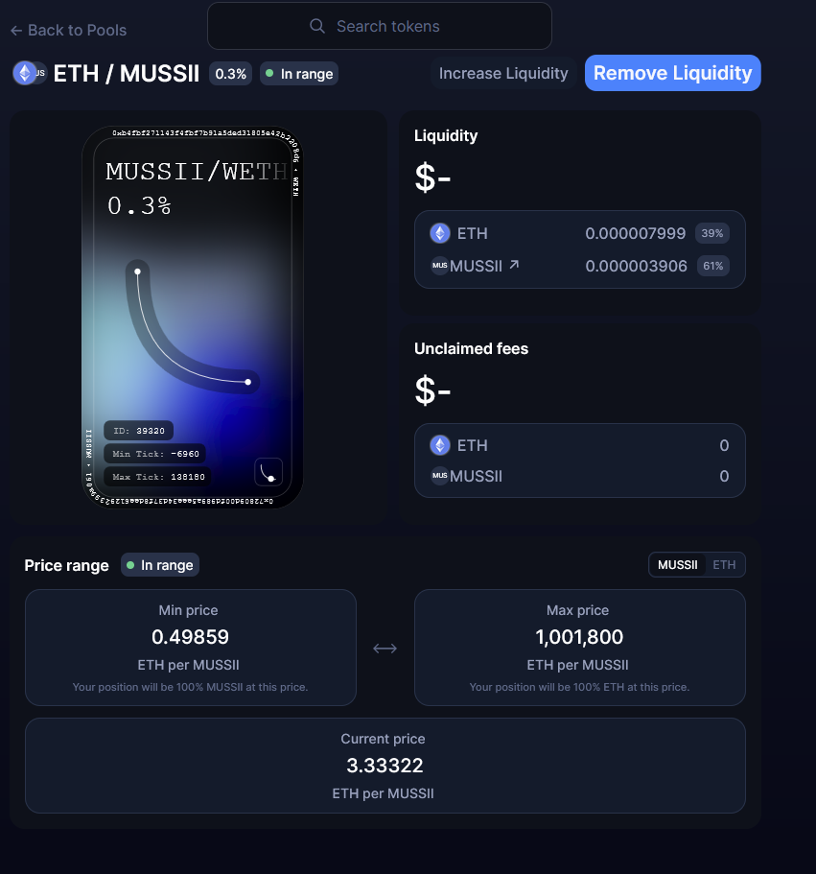

**ARAGON:**

* Connect MetaMask Wallet
* Create a Company DAO on Aragon Protocol
* Configure Voting Rule Of Your Company

**Company Name:** Musaib.aragonid.eth

**Token Name:** MUSSii

**Etherscan URL:** <https://goerli.etherscan.io/tx/0xe4c67e38361f78b3c964981bab2add4a01b17e1064c6d3f826c5782755718d14>

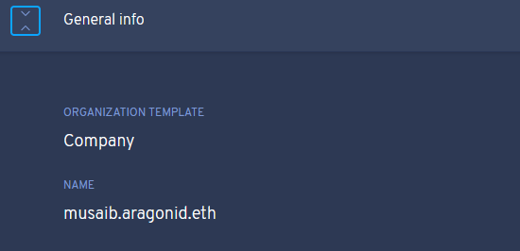

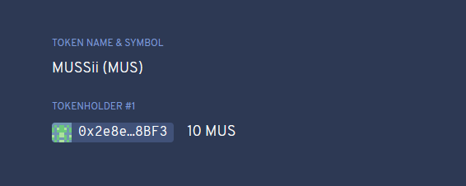

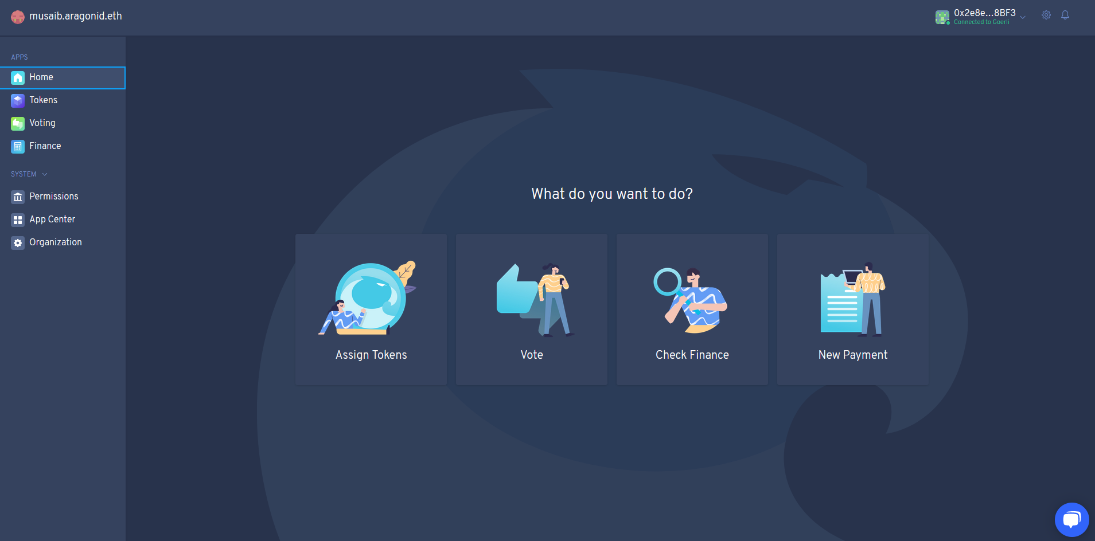

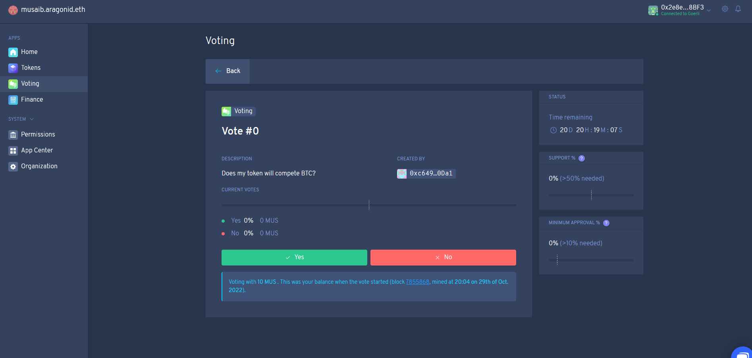

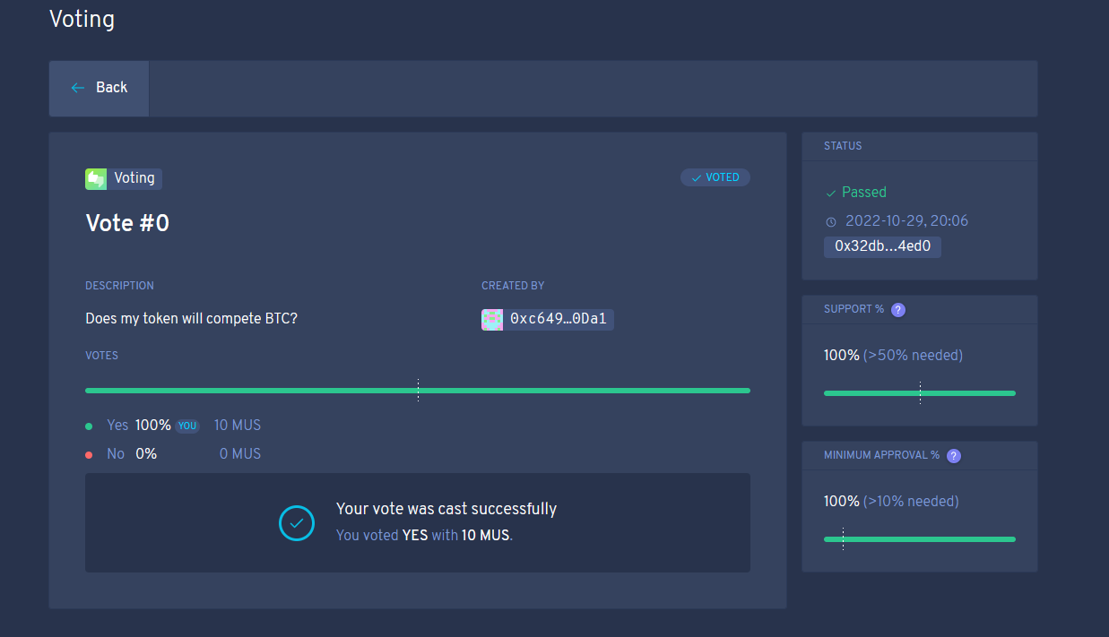

**ENS:**

* Connect MetaMask Wallet
* Register Your Personal Domain at ENS

**Domain Name:** Musaib.eth

**Etherscan URL:** <https://goerli.etherscan.io/tx/0x35149d4bc5e130f47c05d190ffe123ed468f82a2a4ef9e23ec34288d8f82b9fa>

